### **Project 11: Analog（MQ-2）Sensor**

**Description**

This gas sensor is used for household gas leak alarms, industrial combustible gas alarms and portable gas detection instruments. And it is suitable for the detection of liquefied gas, benzene, alkane, alcohol, hydrogen, etc., and widely used in various fire alarm systems. The MQ-2 smoke sensor can be accurately a multi-gas detector, and has the advantages of high sensitivity, fast response, good stability, long life, and simple drive circuit. It can detect the concentration of flammable gas and smoke in the range of 300~10000ppm.Meanwhile, it has high sensitivity to natural gas, liquefied petroleum gas and other smoke, especially to alkanes smoke. It must be heated for a period of time before using the smoke sensor, otherwise the output resistance and voltage are not accurate. However, the heating voltage should not be too high, otherwise it will cause my internal signal line to blow.

It is belongs to the tin dioxide semiconductor gas-sensitive material, and belongs to the surface ion type N-type semiconductor. At a certain temperature, tin dioxide adsorbs oxygen in the air and forms negative ion adsorption of oxygen, reducing the electron density in the semiconductor, thereby increasing its resistance value. When in contact with flammable gas in the air and smog, if the potential barrier at the grain boundary is adjusted by the smog, it will cause the surface conductivity to change. With this, information about the presence of smoke or flammable gas can be obtained. The greater the concentration of smoke or flammable gas in the air, the greater the conductivity, and the lower the output resistance, the larger the analog signal output. The sensor comes with a positioning hole, which is convenient for you to fix the sensor to other devices. In addition, the sensitivity can be adjusted by rotating the potentiometer.

**Specifications:**

* Working voltage: 3.3-5V (DC)
* Interface: 4 pins (VCC, GND, D0, A0)
* Output signal: digital signal and analog signal
* Weight: 7.5g

**Equipment：**

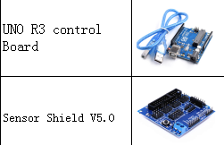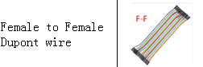

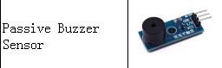

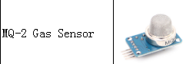

**Connection Diagram：**

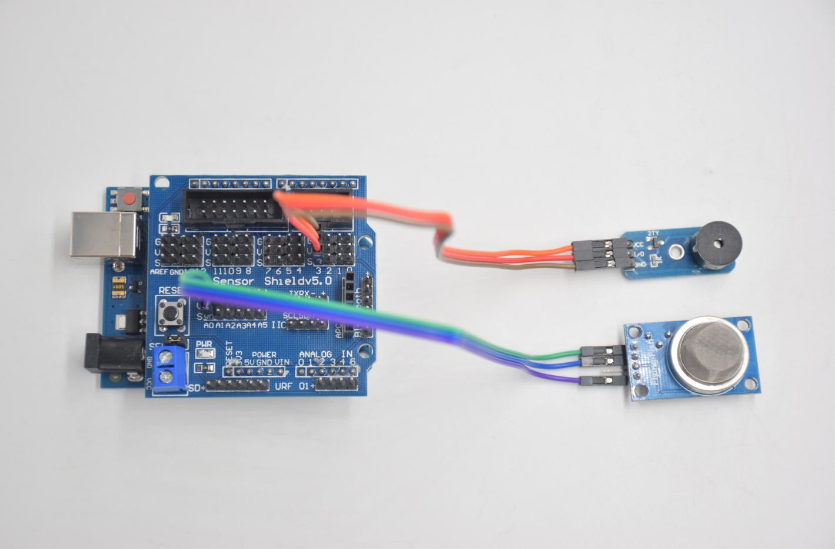

**Passive buzzer Smoke sensor**

**VCC -- 5V AO -- A0**

**I/O -- D3 GND -- GND**

**GND -- GND VCC -- 5V**

**Test Code：**

**int MQ2 = A0; // Define MQ2 gas sensor pin at A0**

**int val = 0; // declare variable**

**int buzzer = 3; // Define the buzzer pin at D3**

**void setup ()**

**{**

**pinMode (MQ2, INPUT); // MQ2 gas sensor as input**

**Serial.begin (9600); // Set the serial port baud rate to 9600**

**pinMode (buzzer, OUTPUT); // Set the digital IO pin mode for output**

**}**

**void loop ()**

**{**

**val = analogRead (MQ2); // Read the voltage value of A0 port and assign it to val**

**Serial.println (val); // Serial port sends val value**

**if (val> 240)**

**{**

**tone (buzzer, 589);**

**delay(300);**

**}**

**else**

**{**

**noTone (buzzer);**

**}**

**}**